Universetoday.com (http://www.universetoday.com/54756/what-is-the-big-bang-theory/)

**Big Bang Theory: Evolution of Our Universe**

*By Matt Williams | December 18, 2015*

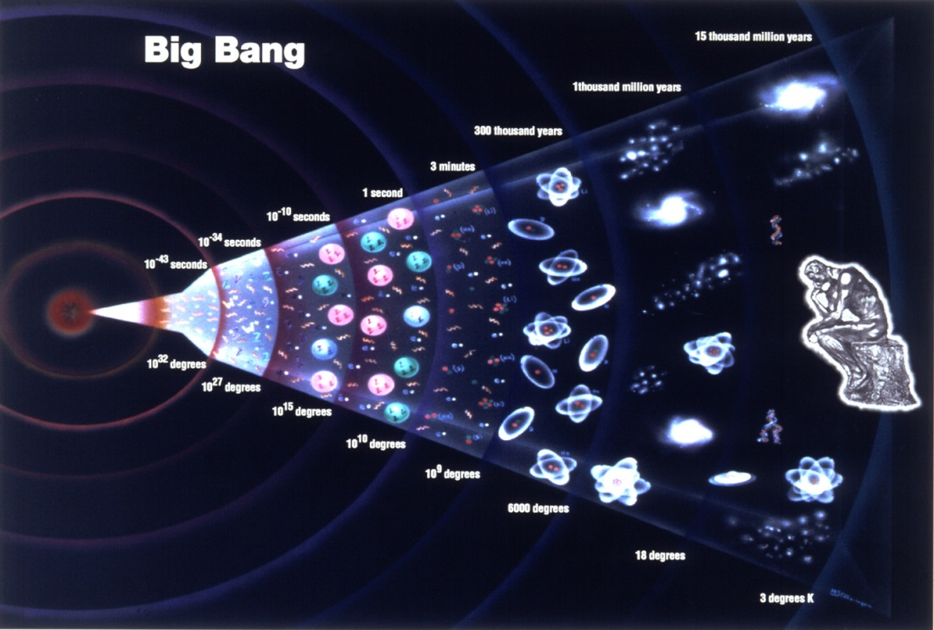

The Big Bang Theory: A history of the Universe starting from a singularity and expanding ever since.

*Credit: grandunificationtheory.com*

How was our Universe created? How did it come to be the seemingly infinite place we know of today? And what will become of it, ages from now? These are the questions that have been puzzling philosophers and scholars since the beginning the time, and led to some pretty wild and interesting theories. Today, the consensus among scientists, astronomers and cosmologists is that the Universe as we know it was created in a massive explosion that not only created the majority of matter, but the physical laws that govern our ever-expanding cosmos. This is known as The Big Bang Theory.

For almost a century, the term has been bandied about by scholars and non-scholars alike. This should come as no surprise, seeing as how it is the most accepted theory of our origins. But what exactly does it mean? How was our Universe conceived in a massive explosion, what proof is there of this, and what does the theory say about the long-term projections for our Universe?

The basics of the Big Bang theory are fairly simple. In short, the Big Bang hypothesis states that all of the current and past matter in the Universe came into existence at the same time, roughly 13.8 billion years ago. At this time, all matter was compacted into a very small ball with infinite density and intense heat called a Singularity. Suddenly, the Singularity began expanding, and the universe as we know it began.

While this is not the only modern theory of how the Universe came into being – for example, there is the Steady State Theory or the Oscillating Universe Theory – it is the most widely accepted and popular. Not only does the model explain the origin of all known matter, the laws of physics, and the large scale structure of the Universe, it also accounts for the expansion of the Universe and a broad range of other phenomena.

**Timeline of the Big Bang Theory**

Working backwards from the current state of the Universe, scientists have theorized that it must have originated at a single point of infinite density and finite time that began to expand. After the initial expansion, the theory maintains that Universe cooled sufficiently to allow the formation of subatomic particles, and later simple atoms. Giant clouds of these primordial elements later coalesced through gravity to form stars and galaxies.

This all began roughly 13.8 billion years ago, and is thus considered to be the age of the universe. Through the testing of theoretical principles, experiments involving particle accelerators and high-energy states, and astronomical studies that have observed the deep universe, scientists have constructed a timeline of events that began with the Big Bang and has led to the current state of cosmic evolution.

However, the earliest times of the Universe – lasting from approximately 10-43 to 10-11 seconds after the Big Bang –  are the subject of extensive speculation. Given that the laws of physics as we know them could not have existed at this time, it is difficult to fathom how the Universe could have been governed. What’s more, experiments that can create the kinds of energies involved have not yet been conducted. Still, many theories prevail as to what took place in this initial instant in time, many of which are compatible.

**Singularity Epoch**

Also known as the Planck Epoch (or Planck Era), this was the earliest known period of the Universe. At this time, all matter was condensed on a single point of infinite density and extreme heat. During this period, it is believed that the quantum effects of gravity dominated physical interactions and that no other physical forces were of equal strength to gravitation.

This Planck period of time extends from point 0 to approximately 10-43 seconds, and is so named because it can only be measured in Planck time. Due to the extreme heat and density of matter, the state of the universe was highly unstable. It thus began to expand and cool, leading to the manifestation of the fundamental forces of physics.

From approximately 10-43 second and 10-36, the universe began to cross transition temperatures. It is here that the fundamental forces that govern the Universe are believed to have began separating from each other. The first step in this was the force of gravitation separating from gauge forces, which account for strong and weak nuclear forces and electromagnetism.

Then, from 10-36 to 10-32 seconds after the Big Bang, the temperature of the universe was low enough (1028 K) that the forces of electromagnetism (strong force) and weak nuclear forces (weak interaction) were able to separate as well, forming two distinct forces.

**Inflation Epoch**

With the creation of the first fundamental forces of the universe, the Inflation Epoch began, lasting from 10-32 seconds in Planck time to an unknown point. Most cosmological models suggest that the Universe at this point was filled homogeneously with a high-energy density, and that the incredibly high temperatures and pressure gave rise to rapid expansion and cooling.

This began at 10-37 seconds, where the phase transition that caused for the separation of forces also led to a period where the universe grew exponentially. It was also at this point in time that baryogenesis occurred, which refers to a hypothetical event where temperatures were so high that the random motions of particles occurred at relativistic speeds.

As a result of this, particle–antiparticle pairs of all kinds were being continuously created and destroyed in collisions, which is believed to have led to the predominance of matter over antimatter in the present universe. After inflation stopped, the universe consisted of a quark–gluon plasma, as well as all other elementary particles. From this point onward, the Universe began to cool and matter coalesced and formed.

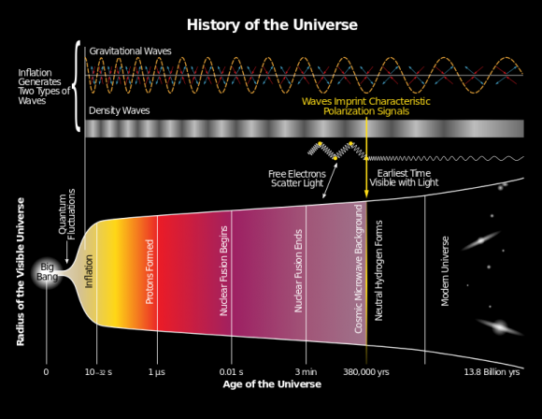

The history of the Universe, from the Big Bang to the current epoch.

Credit: bicepkeck.orgThis

**Cooling Epoch**

As the universe continued to decrease in density and temperature, the energy of each particle began to decrease and phase transitions continued until the fundamental forces of physics and elementary particles changed into their present form. Since particle energies would have dropped to values that can be obtained by particle physics experiments, this period onward is subject to less speculation.

For example, scientists believe that about 10-11 seconds after the Big Bang, particle energies dropped considerably. At about 10-6 seconds, quarks and gluons combined to form baryons such as protons and neutrons, and a small excess of quarks over antiquarks led to a small excess of baryons over antibaryons.

Since temperatures were not high enough to create new proton-antiproton pairs (or neutron-anitneutron pairs), mass annihilation immediately followed, leaving just one in 1010 of the original protons and neutrons and none of their antiparticles. A similar process happened at about 1 second after the Big Bang for electrons and positrons. After these annihilations, the remaining protons, neutrons and electrons were no longer moving relativistically and the energy density of the universe was dominated by photons – and to a lesser extent, neutrinos.

A few minutes into the expansion, the period known as Big Bang nucleosynthesis also began. Thanks to temperatures dropping to 1 billion kelvin and the energy densities dropping to about the equivalent of air, neutrons and protons began to combine to form the universe’s first deuterium (a stable isotope of Hydrogen) and helium atoms. However, most of the Universe’s protons remained uncombined as hydrogen nuclei.

After about 379,000 years, electrons combined with these nuclei to form atoms (again, mostly hydrogen), while the radiation decoupled from matter and continued to expand through space, largely unimpeded. This radiation is now known to be what constitutes the Cosmic Microwave Background (CMB), which today is the oldest light in the Universe.

As the CMB expanded, it gradually lost density and energy, and is currently estimated to have a temperature of 2.7260 ± 0.0013 K (-270.424 °C/ -454.763 °F ) and an energy density of 0.25 eV/cm3 (or 4.005×10-14 J/m3; 400–500 photons/cm3). The CMB can be seen in all directions at a distance of roughly 13.8 billion light years, but estimates of its actual distance place it at about 46 billion light years from the center of the Universe.

**Structure Epoch**

Over the course of the several billion years that followed, the slightly denser regions of the almost uniformly distributed matter of the Universe began to become gravitationally attracted to each other. They therefore grew even denser, forming gas clouds, stars, galaxies, and the other astronomical structures that we regularly observe today.

This is what is known as the Structure Epoch, since it was during this time that the modern Universe began to take shape. This consists of visible matter distributed in structures of various sizes, ranging from stars and planets to galaxies, galaxy clusters, and super clusters – where matter is concentrated – that are separated by enormous gulfs containing few galaxies.

The details of this process depend on the amount and type of matter in the universe, with cold dark matter, warm dark matter, hot dark matter, and baryonic matter being the four suggested types. However, the Lambda-Cold Dark Matter model (Lambda-CDM), in which the dark matter particles moved slowly compared to the speed of light, is the considered to be the standard model of Big Bang cosmology, as it best fits the available data.

In this model, cold dark matter is estimated to make up about 23% of the matter/energy of the universe, while baryonic matter makes up about 4.6%. The Lambda refers to the Cosmological Constant, a theory originally proposed by Albert Einstein that attempted to show that the balance of mass-energy in the universe was static. In this case, it is associated with Dark Energy, which served to accelerate the expansion of the universe and keep its large-scale structure largely uniform.

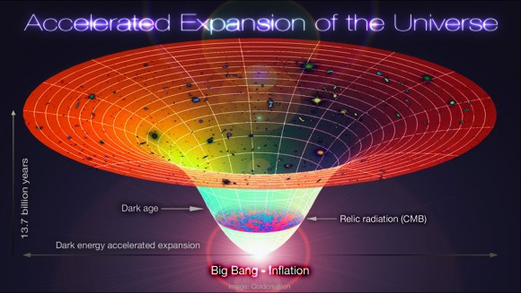

Diagram showing the Lambda-CBR universe, from the Big Bang to the the current era.

Credit: Alex Mittelmann/Coldcreation

**Long-term Predictions for the Future of the Universe**

Hypothesizing that the Universe had a starting point naturally gives rise to questions about a possible end point. If the Universe began as a tiny point of infinite density that started to expand, does that mean it will continue to expand indefinitely? Or will it one day run out of expansive force, and begin retreating inward until all matter crunches back into a tiny ball?

Answering this question has been a major focus of cosmologists ever since the debate about which model of the Universe was the correct one began. With the acceptance of the Big Bang Theory, but prior to the observation of Dark Energy in the 1990s, cosmologists had come to agree on two scenarios as being the most likely outcomes for our Universe.

In the first, commonly known as the “Big Crunch” scenario, the universe will reach a maximum size and then begin to collapse in on itself. This will only be possible if the mass density of the Universe is greater than the critical density. In other words, as long as the density of matter remains at or above a certain value (1-3 ×10-26 kg of matter per m³), the Universe will eventually contract.

Alternatively, if the density in the universe were equal to or below the critical density, the expansion would slow down but never stop. In this scenario, known as the “Big Freeze”, the Universe would go on until star formation eventually ceased with the consumption of all the interstellar gas in each galaxy. Meanwhile, all existing stars would burn out and become white dwarfs, neutron stars, and black holes.

Very gradually, collisions between these black holes would result in mass accumulating into larger and larger black holes. The average temperature of the universe would approach absolute zero, and black holes would evaporate after emitting the last of their Hawking radiation. Finally, the entropy of the universe would increase to the point where no organized form of energy could be extracted from it (a scenarios known as “heat death”).

Modern observations, which include the existence of Dark Energy and its influence on cosmic expansion, have led to the conclusion that more and more of the currently visible universe will pass beyond our event horizon (i.e. the CMB, the edge of what we can see) and become invisible to us. The eventual result of this is not currently known, but “heat death” is considered a likely end point in this scenario too.

Other explanations of dark energy, called phantom energy theories, suggest that ultimately galaxy clusters, stars, planets, atoms, nuclei, and matter itself will be torn apart by the ever-increasing expansion. This scenario is known as the “Big Rip”, in which the expansion of the Universe itself will eventually be its undoing.

**History of the Big Bang Theory**

The earliest indications of the Big Bang occurred as a result of deep-space observations conducted in the early 20th century. In 1912, American astronomer Vesto Slipher conducted a series of observations of spiral galaxies (which were believed to be nebulae) and measured their Doppler Redshift. In almost all cases, the spiral galaxies were observed to be moving away from our own.

In 1922, Russian cosmologist Alexander Friedmann developed what are known as the Friedmann equations, which were derived from Einstein’s equations for general relativity. Contrary to Einstein’s was advocating at the time with his a Cosmological Constant, Friedmann’s work showed that the universe was likely in a state of expansion.

In 1924, Edwin Hubble’s measurement of the great distance to the nearest spiral nebula showed that these systems were indeed other galaxies. At the same time, Hubble began developing a series of distance indicators using the 100-inch (2.5 m) Hooker telescope at Mount Wilson Observatory. And by 1929, Hubble discovered a correlation between distance and recession velocity – which is now known as Hubble’s law.

And then in 1927, Georges Lemaitre, a Belgian physicist and Roman Catholic priest, independently derived the same results as Friedmann’s equations and proposed that the inferred recession of the galaxies was due to the expansion of the universe. In 1931, he took this further, suggesting that the current expansion of the Universe meant that the father back in time one went, the smaller the Universe would be. At some point in the past, he argued, the entire mass of the universe would have been concentrated into a single point from which the very fabric of space and time originated.

These discoveries triggered a debate between physicists throughout the 1920s and 30s, with the majority advocating that the universe was in a steady state. In this model, new matter is continuously created as the universe expands, thus preserving the uniformity and density of matter over time. Among these scientists, the idea of a Big Bang seemed more theological than scientific, and accusations of bias were made against Lemaitre based on his religious background.

Other theories were advocated during this time as well, such as the Milne Model and the Oscillary Universe model. Both of these theories were based on Einstein’s theory of general relativity (the latter being endorsed by Einstein himself), and held that the universe follows infinite, or indefinite, self-sustaining cycles.

After World War II, the debate came to a head between proponents of the Steady State Model (which had come to be formalized by astronomer Fred Hoyle) and proponents of the Big Bang Theory – which was growing in popularity. Ironically, it was Hoyle who coined the phrase “Big Bang” during a BBC Radio broadcast in March 1949, which was believed by some to be a pejorative dismissal (which Hoyle denied).

Eventually, the observational evidence began to favor Big Bang over Steady State. The discovery and confirmation of the cosmic microwave background radiation in 1965 secured the Big Bang as the best theory of the origin and evolution of the universe. From the late 60s to the 1990s, astronomers and cosmologist made an even better case for the Big Bang by resolving theoretical problems it raised.

These included papers submitted by Stephen Hawking and other physicists that showed that singularities were an inevitable initial condition of general relativity and a Big Bang model of cosmology. In 1981, physicist Alan Guth theorized of a period of rapid cosmic expansion (aka. the “Inflation” Epoch) that resolved other theoretical problems.

The 1990s also saw the rise of Dark Energy as an attempt to resolve outstanding issues in cosmology. In addition to providing an explanation as to the universe’s missing mass (along with Dark Matter, originally proposed in 1932 by Jan Oort), it also provided an explanation as to why the universe is still accelerating, as well as offering a resolution to Einstein’s Cosmological Constant.

Significant progress was made thanks to advances in telescopes, satellites, and computer simulations, which have allowed astronomers and cosmologists to see more of the universe and gain a better understanding of its true age. The introduction of space telescopes – such as the Cosmic Background Explorer (COBE), the Hubble Space Telescope, Wilkinson Microwave Anisotropy Probe (WMAP) and the Planck Observatory – have also been of immeasurable value.

Today, cosmologists have fairly precise and accurate measurements of many of the parameters of the Big Bang Theory model, not to mention the age of the Universe itself. And it all began with the noted observation that massive stellar objects, many light years distant, were slowly moving away from us. And while we still are not sure how it will all end, we do know that on a cosmological scale, that won’t be for a long, LONG time!